Memorandum

|  |  |
| --- | --- |
| To: | City of Sparks |
| From: | Economic & Planning Systems |
| Subject: | Fiscal Impact Methodology |
| Date: | July 29, 2019 |

This memorandum provides an overview of the fiscal impact methodology developed by Economic & Planning Systems (EPS) to help to City of Sparks better understand the fiscal impacts of new development.

In an effort to better understand the fiscal impact of development EPS was contracted by the City of Sparks to develop a fiscal impact model that will measure the fiscal impact of proposals for individual development projects on the City’s finances. With the understanding that solely evaluating the impact of individual projects does not provide a holistic overview of the City’s overall fiscal health, subsequent analysis will provide a more general overview of the City’s overall fiscal condition.

This memo provides an overview of fiscal impact methodology and summary of the key factors driving the current analysis.

Budget Structure

The primary purpose of fiscal impact analysis is to evaluate the fiscal impacts of residential and commercial development on major City expenditures and revenue sources. The focus of this analysis is on City funds with expenditures or revenues that are directly impacted by growth. As a result, this analysis primarily focuses on fiscal impacts on two City funds that include the General Fund and the Road Fund. The General Fund is the City’s largest fund and is primarily responsible for funding general management government services, the Police Department, the Fire Department, and other community services. The Road Fund provides for maintenance, repair, acquisition, and construction of local roads and streets in the City.

It is also important to note that there are a number of Enterprise Funds that are impacted by development, such as the Sewer Operations Fund and the Development Services Fund. The impact of development on these funds is, however, not estimated due to the fact that these funds receive the majority of their revenues from user fees that in theory are adjusted to account for new development.

## General Fund Revenues

The General Fund’s primary revenue sources come from Consolidated Tax Revenue (CTAX), Property Taxes and licenses & permits. Together, these sources account for 93 percent of total General Fund revenues. Actual 2017 General Fund revenues are summarized in **Figure 1**.

Figure 1   
General Fund Revenue, City of Sparks, 2017

### CTAX and Fair Share Revenue

#### Overview

In 2017, the City received approximately $25.1 million in what is known as consolidated tax (CTAX), which includes the following components:

* Cigarette Tax
* Liquor Tax
* Government Services Tax (GST)
* Real Property Transfer Tax (RPPT)
* Basic City County Relief Tax (BCCRT)
* Supplemental City County Relief Tax (SCCT)

These sales taxes are collected by the State of Nevada and distributed by the State to the various government agencies. The City of Sparks receives an annual amount distributed through Washoe County. Revenue received by the City of Sparks is distributed by the County according to Base and Excess Distribution formulas. The Base Distribution was determined in 1997, when CTX was established, and is recalculated annually to reflect changes in the Consumer Price Index (CPI). The Excess Distribution is the amount of revenue available to distribute after the Base Distribution has been made. Excess is distributed based on a formula combining the five-year moving average of the changes in population and assessed valuation for the City. The other significant source of revenue in this category is the distribution of revenue from County gaming licenses.

#### Impacts of Development

Growth in revenue to the City from sales tax is most impacted by the growth of the overall population of Washoe County. Due to the State of Nevada’s laws and procedures related to the distribution of CTX, the City’s annual distribution of revenue generally grows as the County grows and typically equates to 20 percent of the County’s distribution. While it is generally assumed that more retail sales occurring in Sparks (versus elsewhere in Washoe County) would lead to more sales tax revenue, the impact of where the sale takes place is minimal and difficult to quantify due to the way the State collects and distributes sales tax revenues. In terms of this fiscal impact analysis, the location of retail (and the sales tax generated by retail) only significantly impacts Sparks if the retail sales are occurring just outside Washoe County (neighboring counties or Indian Reservations).

In terms of the CTX revenues received by the City of Sparks, it is important to evaluate the impact of development on the Base Distribution and the Excess Distribution separately. For the purposes of this analysis, it is assumed that development or growth has no impact on the Base Distribution amount due to the fact that the Base Distribution is purely based on the previous year’s distribution adjusted for inflation. The Excess Distribution, which typically amounts to approximately 20 percent of the Total Distribution, is assumed to be impacted by growth and is consequently included in the estimate of future revenues in this analysis.

### Property Tax

#### Overview

The second largest revenue category for the General Fund is property tax with estimated revenue in 2017 of $21.0 million. The total overlapping tax rate for the City of Sparks in 2017/2018 was $3.66 per $100 of assessed valuation. Assessed value is calculated as 35 percent of the replacement value of property. Of the $3.66 per $100, the City of Sparks gets $0.9598 per $100 of which 100 percent goes to the General Fund.

#### Impacts of Development

The amount of property tax generated by the City is dependent on the value of existing developed property and the addition of new development to undeveloped parcels. Developing vacant property to higher valued uses generates more property tax. Also generating increased property tax is the increase in value of existing properties through additions, renovation, and/or redevelopment.

Property value is determined through two measurements: the assessment of the value of the land and the assessment of the value of the improvements (buildings) on the land. The value of land varies depending on the location of the property and matches with differences in total market value in different geographies. The improvement value is determined through an assessment of replacement value (performed at least every five years) multiplied by a replacement factor that estimates the replacement cost of a building based on the use, age, and obsolescence of a building. In effect, the replacement value of a building or improvement is decreased by 1.5 percent annually for 50 years (assuming no major changes to a building). Therefore, the property tax generated from the value of land is fairly consistent by parcel (impacted by geography), but the revenue from a property improvements are greatly impacted by the age of the improvement.

This approach to valuation increases the reliance on new development for property tax revenues, as no growth will produce diminishing returns in property tax revenue compared to costs that hypothetically are flat (or increasing with inflation). The increase in a property tax bill (assuming no change in use, new building or additions, or changes to parcel boundary) is also capped annually to an increase of 3 percent for residential parcels that are owner occupied, that are used as a primary residence, or that are rental units that rent for less than HUD median market rents.

### Business Licenses and Other Revenues

#### Overview

The third largest revenue category in the General Fund is business licenses and other revenues, which were roughly $9.0 million in 2017. The specific composition of these revenue sources is one of the outstanding questions that EPS would like to discuss in greater detail with staff and is summarized in subsequent sections of this memo.

#### Impacts of Development

The revenue from businesses licenses and other revenues are assumed to generally increases with the growth of the City’s population and employment base. Businesses licenses are generated by the number of establishments in the City of Sparks and represent one of the few major revenue sources that vary between residential and non-residential uses.

## General Fund Expenditures

The expenditures in the City’s General Fund fall within 10 major categories or departments. These expenditures per department are shown in **Figure 2.** Two departments account for the majority of the expenditures in the General Fund: Police and Fire. The budget for the Police Department in 2017 is $17.3 million and the budget for the Fire Department is $10.7 million. Development has a major fiscal impact for both departments. The other two departments most impacted by new development are Community Services and general Management Services. The estimated impact of growth for these four departments specifically and the other departments will be estimated using a variety of approaches, which are described in subsequent sections of this memorandum.

Figure 2

General Fund Expenditures, City of Sparks, 2017

## Road Fund Revenues

#### Overview

The City’s Road Fund is funded through a variety of revenue sources that include franchise fees, State gasoline tax, and a number of other fees and taxes. Total fund revenue was $4.8 million in 2017 of which $1.4 million was generated by electric franchise fees, $1.8 million was generated by State gasoline tax, and $1.7 million was generated by other sources, as shown in **Figure 3**.

#### Impacts of Development

Similar to some of the General Funds miscellaneous revenue sources, revenues to the City’s Road Fund are assumed to be relatively closely correlated to increases in population and employment.

Figure 3   
Road Fund Revenue, City of Sparks, 2017

## Road Fund Expenditures

As one would expect, the majority of revenue received by the Road Fund is used to fund capital replacement road projects throughout the City. In 2017, $4.5 million was dedicated to Capital Outlay, which represents 60 percent of total fund expenditures. The impact of growth on the Road Fund is estimated on a per road mile basis, as discussed in greater detail in subsequent sections of this memo.

Figure 4   
Road Fund Expenditures, City of Sparks, 2017

# Fiscal Analysis Methodology

The purpose of fiscal impact analysis is to provide an objective estimate of the costs and revenue impacts to the City of new development in a variety of contexts. The analysis compares the estimated revenues generated by new development to the estimated costs of public services required to determine the net fiscal impact. Revenues and costs are estimated based on the budgets for each fund and department, and an assessment of potential effects of different types of development on each department or budget category. Certain revenue items are estimated using “case study” approaches based on formulas; for example, property tax is based on estimated assessed values multiplied by the applicable tax rates. Other items, such as public service costs related to residential development, are based on average cost factors (such as “per capita” estimate). The revenue sources and expenditures that have the largest impact on the budget and are most directly tied to growth will have a specific case study developed for them, while other revenues and expenditures will be estimated using average cost factors.

## Average Cost Nexus Factors

EPS developed nexus factors that relate to the budget item being estimated to the service population or other metric that is best associated with the impact. These factors are discussed below in greater detail.

* **Peak Persons Served (Residents and Employees) –** Many services are affected by growth in both residents and employees. The purpose of this factor is to derive a peak population of persons served within the City. The number of people each use generates is estimated on average person generation factor for each use (average residents per household for single family and multifamily, and the average number of employees per square foot for retail, office, and industrial). Using the persons served approach means each new use will generate a number of people (i.e., one new single family housing unit will generate 2.48 people) which will be used to estimate costs and revenues based on the number of people use generates and average cost per person.
* **Per Unit –** Functions, such as business or liquor licenses, that serve specific land uses, such as commercial development, are estimated on a unit factor of 1,000 square feet of commercial/industrial space per unit or per residential unit.
* **Street Lane Miles –** Impacts to the Road Fund are estimated on the basis of “centerline miles” for portions of those funds expenditures related to maintenance and capital improvements. The City maintains a certain amount of local and collector roads and, as a result, a new development’s impact will be evaluated based on the amount of street miles needed to serve the development and the average cost per centerline.

## Fixed and Variable Cost Adjustments

Directly applying the factors described above to new growth would be equivalent to using the average cost for each item, which can overstate cost impacts. For local governments whose services are at or near capacity, the average cost method is a generally accepted technique for estimating fiscal impacts. However, many functions still need to be adjusted to account for higher levels of fixed cost and/or a less direct relation to growth. The following process and assumptions were used in developing the “Percent Variable” adjustments to average costs.

* **Administrative and General Government** – Departments such as the City Council, City Manager, finance, communications and technology, human resources, and other department management functions have a high level of fixed costs regardless of the size of a City.   
  Costs in these types of departments and functions are estimated to be 25 percent variable.
* **Growth Impacted Departments –** These include services such as development services (community development), municipal court, and dispatch. These types of services are estimated to be much more closely related to growth and increased population and are modeled using the average cost methodology or 100 percent variable.
* **Functions with No Nexus or Relevance –** Some City functions were determined not to have any relationship to real estate development projects.

## City Revenues

A summary of the City’s primary revenue sources and corresponding nexus to growth and 2017 amount is summarized in **Table 2**. In addition, a description of the methodology used to estimate the City’s primary revenue sources is provided below.

### CTAX

Due to the way the State of Nevada collects and distributes CTX, the generation of sales tax from new development is based on the forecasted growth of the County and the use of a peak person factor that ties retail sales to the number people generated by a use and not where the actual retail sale is made. It is important to note that the Base Distribution is assumed to have no nexus to growth and as a result is not estimated in this analysis.[1] The remaining 20 percent that makes up the Excess distribution is forecasted based on the peak person served methodology.

### Property Tax

Property tax is estimated based on estimates of the average value of new development by each major land use (single family, multifamily, office, retail and industrial). The average value will be factored down to 35 percent to estimate the assessed value of new development, and the property tax rate for the City’s General Fund will be applied to estimate property tax ($0.9598 per $100 of assessed value). Property tax is estimated based on the estimated average value of new development by each major land use (single family, multifamily, office, retail and industrial). Estimated market value is factored down by 65 percent (i.e. 35 percent of estimated value) to approximate the assessed value of new development. The property tax rate for the City’s General Fund ($0.9598 per $100 of assessed value) is applied to assessed value to estimate property tax revenues.

Due to the property taxation structure in Nevada and the impact of depreciation on assessed property values and corresponding property taxes, an annual rate of 0.5 percent of property appreciation is applied to property values used to estimate property tax revenue. This rate is based off a review of assessed values and property tax records for comparable properties over a 20 year period. The factor assumes escalation of property values net of the impact of annual depreciation of improvement value over a 20 year period.

### Other Revenue Sources

The majority of other revenue sources are estimated using a peak person factor, with the exception of a few revenue sources. Business licenses and fees that apply to only certain types of uses (i.e., business licenses, liquor licenses) will be applied on a per unit (either residential unit or equivalent commercial unit) basis.

Table 2   
Nexus to Growth and Variability: Revenues



## City Expenditures

A summary of the City’s major departments and their corresponding nexus to growth, variability, and 2017 budget is summarized in **Table 1**.

The expenditures in the General Fund are estimated using a peak person factor or a per unit factor depending on the specific sub-department. For Police and Fire specific case studies were developed to estimate fiscal impacts.

### Police

In order to estimate future costs that the Police department will incur, EPS relied on call volume data that was provided by the Police department. This data is organized by the use that is generating the call (i.e., residential, office, retail, etc.) determined by the geographic location of the call. This approach more closely ties the cost of police service to the uses that are generating that service. As a result, retail uses have the highest per unit cost because retail uses generate a higher number of police calls for both crime prevention and traffic incidents based on the geographic distribution of calls.

The impact on police services is based on the calls for service generated by a particular land use. This approach closely ties the cost of police service to the uses that are generating that service. The estimated costs per unit (residential) and per 1,000 square feet of development (non-residential) were developed.

### Fire

In order to estimate future costs that the Fire Department will incur, EPS relied on call volume data that was provided by the Fire Department by fire station, and the service area of each fire station. The Fire Department is required to meet certain level of service standards that are related to response time. Unlike a police officer that is typically out on patrol while on duty, Firemen and their fire engines typically return to the station in between calls. As well, in areas with lower population and employment density, the call volume for a fire station can be much less than a station in a more densely populated area. Therefore, the impact of new development can vary depending on the part of the City it occurs in.

The City of Sparks Fire Department has a 4.5-minute response time standard. Unlike a police officer that is typically out on patrol while on duty, firefighters and their fire engines typically return to the station in between calls. In areas with lower population and employment density, the call volume for a fire station can be much less than a station in a more densely populated area. Also, areas of the City can be too far from existing fire stations to meet response time standards, which can create safety issues. There are portions of the City where that is the case today. One example is in the northwest corner of the City and is currently served by either fire station 4 or 5. As well, the City of Sparks has a joint service agreement with the Truckee Meadows Fire Protection District, which primarily serves the unincorporated portion of Washoe County, provides service to this area in many cases. A sixth fire station is needed to serve this area (illustrated in **Figure 1**) but capital funding and revenues needed to operate the station do not currently exist. Therefore, the impact of new development can vary depending on the part of the City it occurs in. Areas of the City that are outside the fire service areas for existing stations and newly annexed areas are estimated to have a higher cost for service due a lower anticipated peak population in this area. **Figure 1** and **Table 4** indicate the locations and associated cost multiplier to serve areas outside of existing fire station areas.

Table 3   
Fire Service Cost Multiplier for Outside Fire Station Service Areas



Figure 1

Fire Station Service Areas

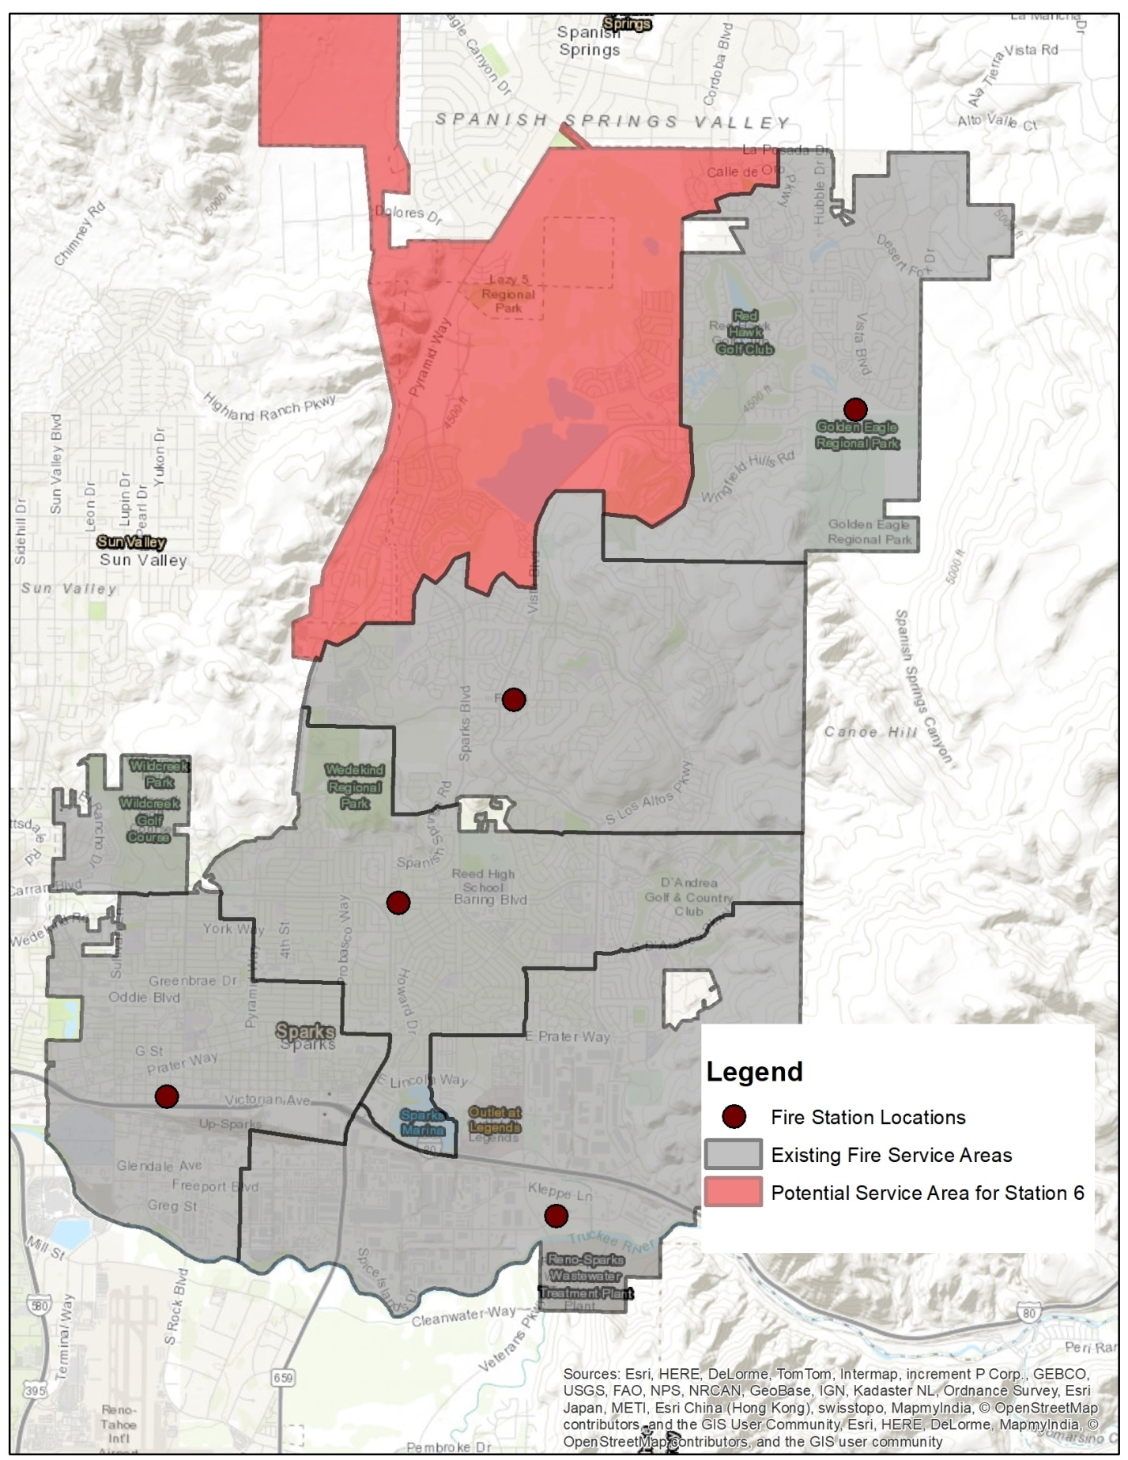

### Road Fund

Expenditures for the Road Fund are estimated based on the current average expenditure per City centerline mile and the number of centerlines future development types are estimated to generate. Varying assumptions regarding density are used to convert residential units or commercial area to centerline miles.

#### Road Fund

Expenditures for the Road Fund are estimated based on the current average annual expenditure per square foot of pavement maintained by the City. The annual maintenance and replacement cost per square foot of pavement within the City is $0.44 per square foot. The location of the City’s fleet and roadway maintenance yards are in the southern portion of the City. This location makes service to areas of the northern portion of the City more expensive as the crew and materials need to be transported longer distances to make repairs. Factors for various portions of the City for road maintenance costs were developed based on average drive time. Portions of the City within the McCarren Loop (area 1) have the lowest cost, while areas in the north portion of the city (area 3) have the highest. The service areas are shown in **Figure 2**.The service areas cost multipliers are shown in **Table 4.** The Road Fund annual cost factors are provided in **Table 5**.

Table 4

Road Fund Cost Multiplier by Area



Table 5

Road Fund Cost Factors



Figure 2

Road Fund Service Areas

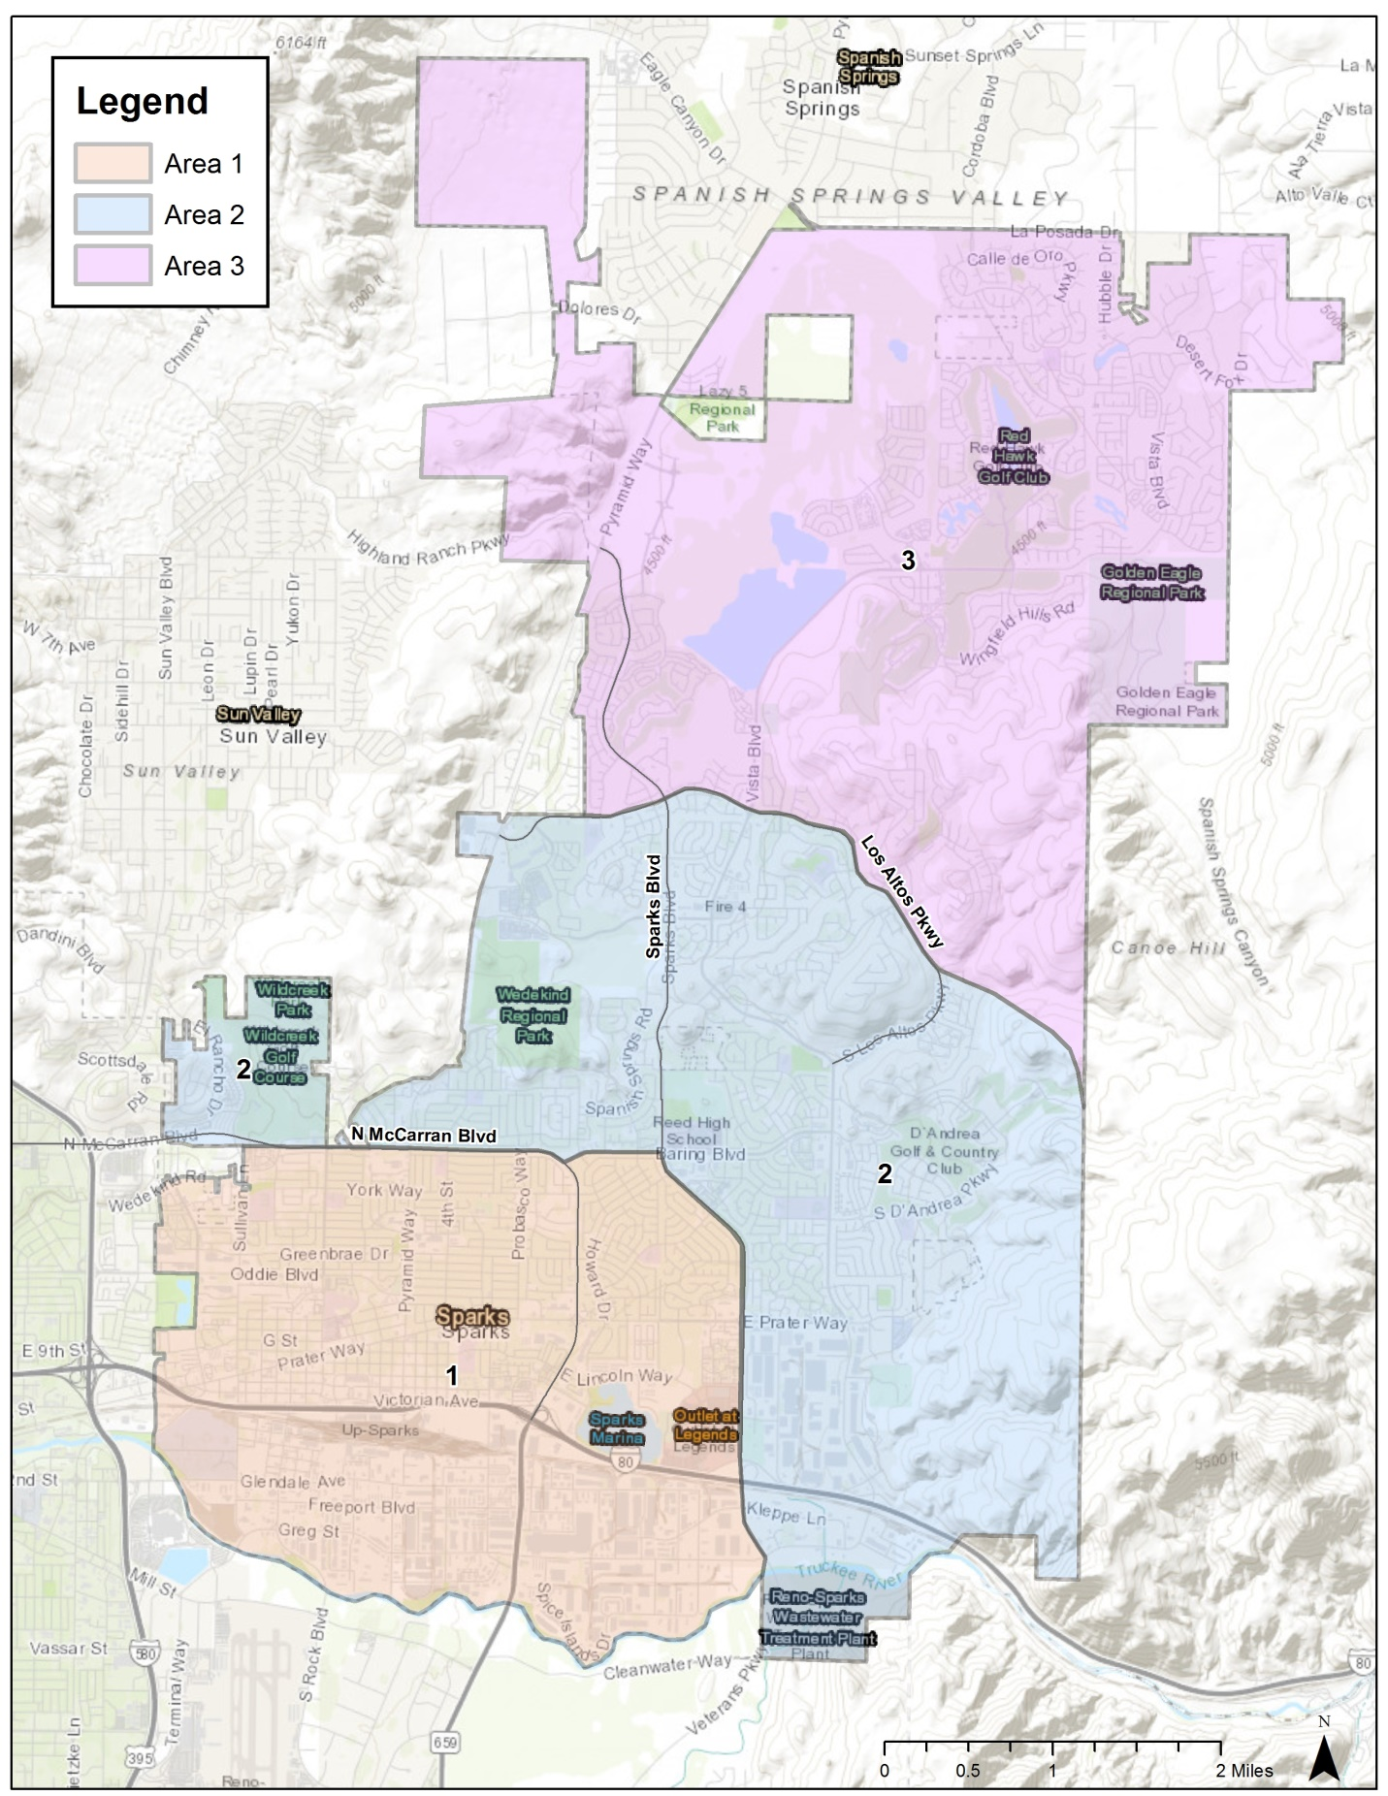

### Other General Fund Expenditures

The remainder of General Fund expenditures are estimated using a per person served average cost factor. In addition, a variability factor was applied to each sub-department to account for expenditures not impacted by growth and fixed costs.

Table 1   
Nexus to Growth and Variability: Expenditures



1. In order to avoid overstating expenditures, revenues the City receives from the Base Distribution are subtracted from annual expenditures based on a pro rata share of each expenditure item’s proportion of the total.